DIS-PORTRAIT-hudjihini

**Eagle of Delight**, also called **Hayne Hudjihini** in [Chiwere](https://en.wikipedia.org/wiki/Chiwere_language) (b. c. 1795 - d. 1822), was one of the five wives of Chief [Shaumonekusse](https://en.wikipedia.org/wiki/Shaumonekusse) of the [Otoe tribe](https://en.wikipedia.org/wiki/Otoe_tribe) in the first quarter of the 19th century.[[1]](https://en.wikipedia.org/wiki/Eagle_of_Delight" \l "cite_note-1) They were based in present-day [Nebraska](https://en.wikipedia.org/wiki/Nebraska).

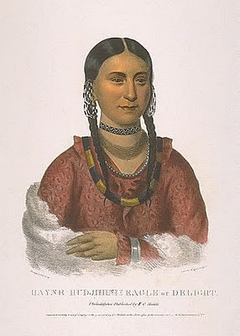

Philadelphia: Key & Biddle, 1833. Hand-coloured lithograph. In excellent condition. Image size (including text): 11 1/2 x 8 inches. Sheet size: 18 7/8 x 13 1/4 inches. A fine image from McKenney and Hall's 'Indian Tribes of North America': `One of the most important (works) ever published on the American Indians' (Field), ` a landmark in American culture' (Horan) and an invaluable contemporary record of a vanished way of life.This very nice example of Hayne Hudjihini's portrait gives a hint of the beauty and charm that captivated President Monroe, Thomas McKenney and members of the Cabinet. She was one of Shaumonekusse's five wives, and was thought to be the most beautiful of all the Native American wives who visited Washington. She was eighteen or nineteen when King painted her portrait. Sadly, she died of the measles soon after returning home.McKenney and Hall's 'Indian Tribes of North America' has long been renowned for its faithful portraits of Native Americans. The portraits are largely based on paintings by the artist Charles Bird King, who was employed by the War Department to paint the Indian delegates visiting Washington D.C., forming the basis of the War Department's Indian Gallery. Most of King's original paintings were subsequently destroyed in a fire at the Smithsonian, and their appearance in McKenney and Hall's magnificent work is thus our only record of the likenesses of many of the most prominent Indian leaders of the nineteenth century. Numbered among King's sitters were Sequoyah, Red Jacket, Major Ridge, Keokuk, and Black Hawk. After six years as Superintendent of Indian Trade, Thomas McKenney had become concerned for the survival of the Western tribes. He had observed unscrupulous individuals taking advantage of the Native Americans for profit, and his vocal warnings about their future prompted his appointment by President Monroe to the Office of Indian Affairs.

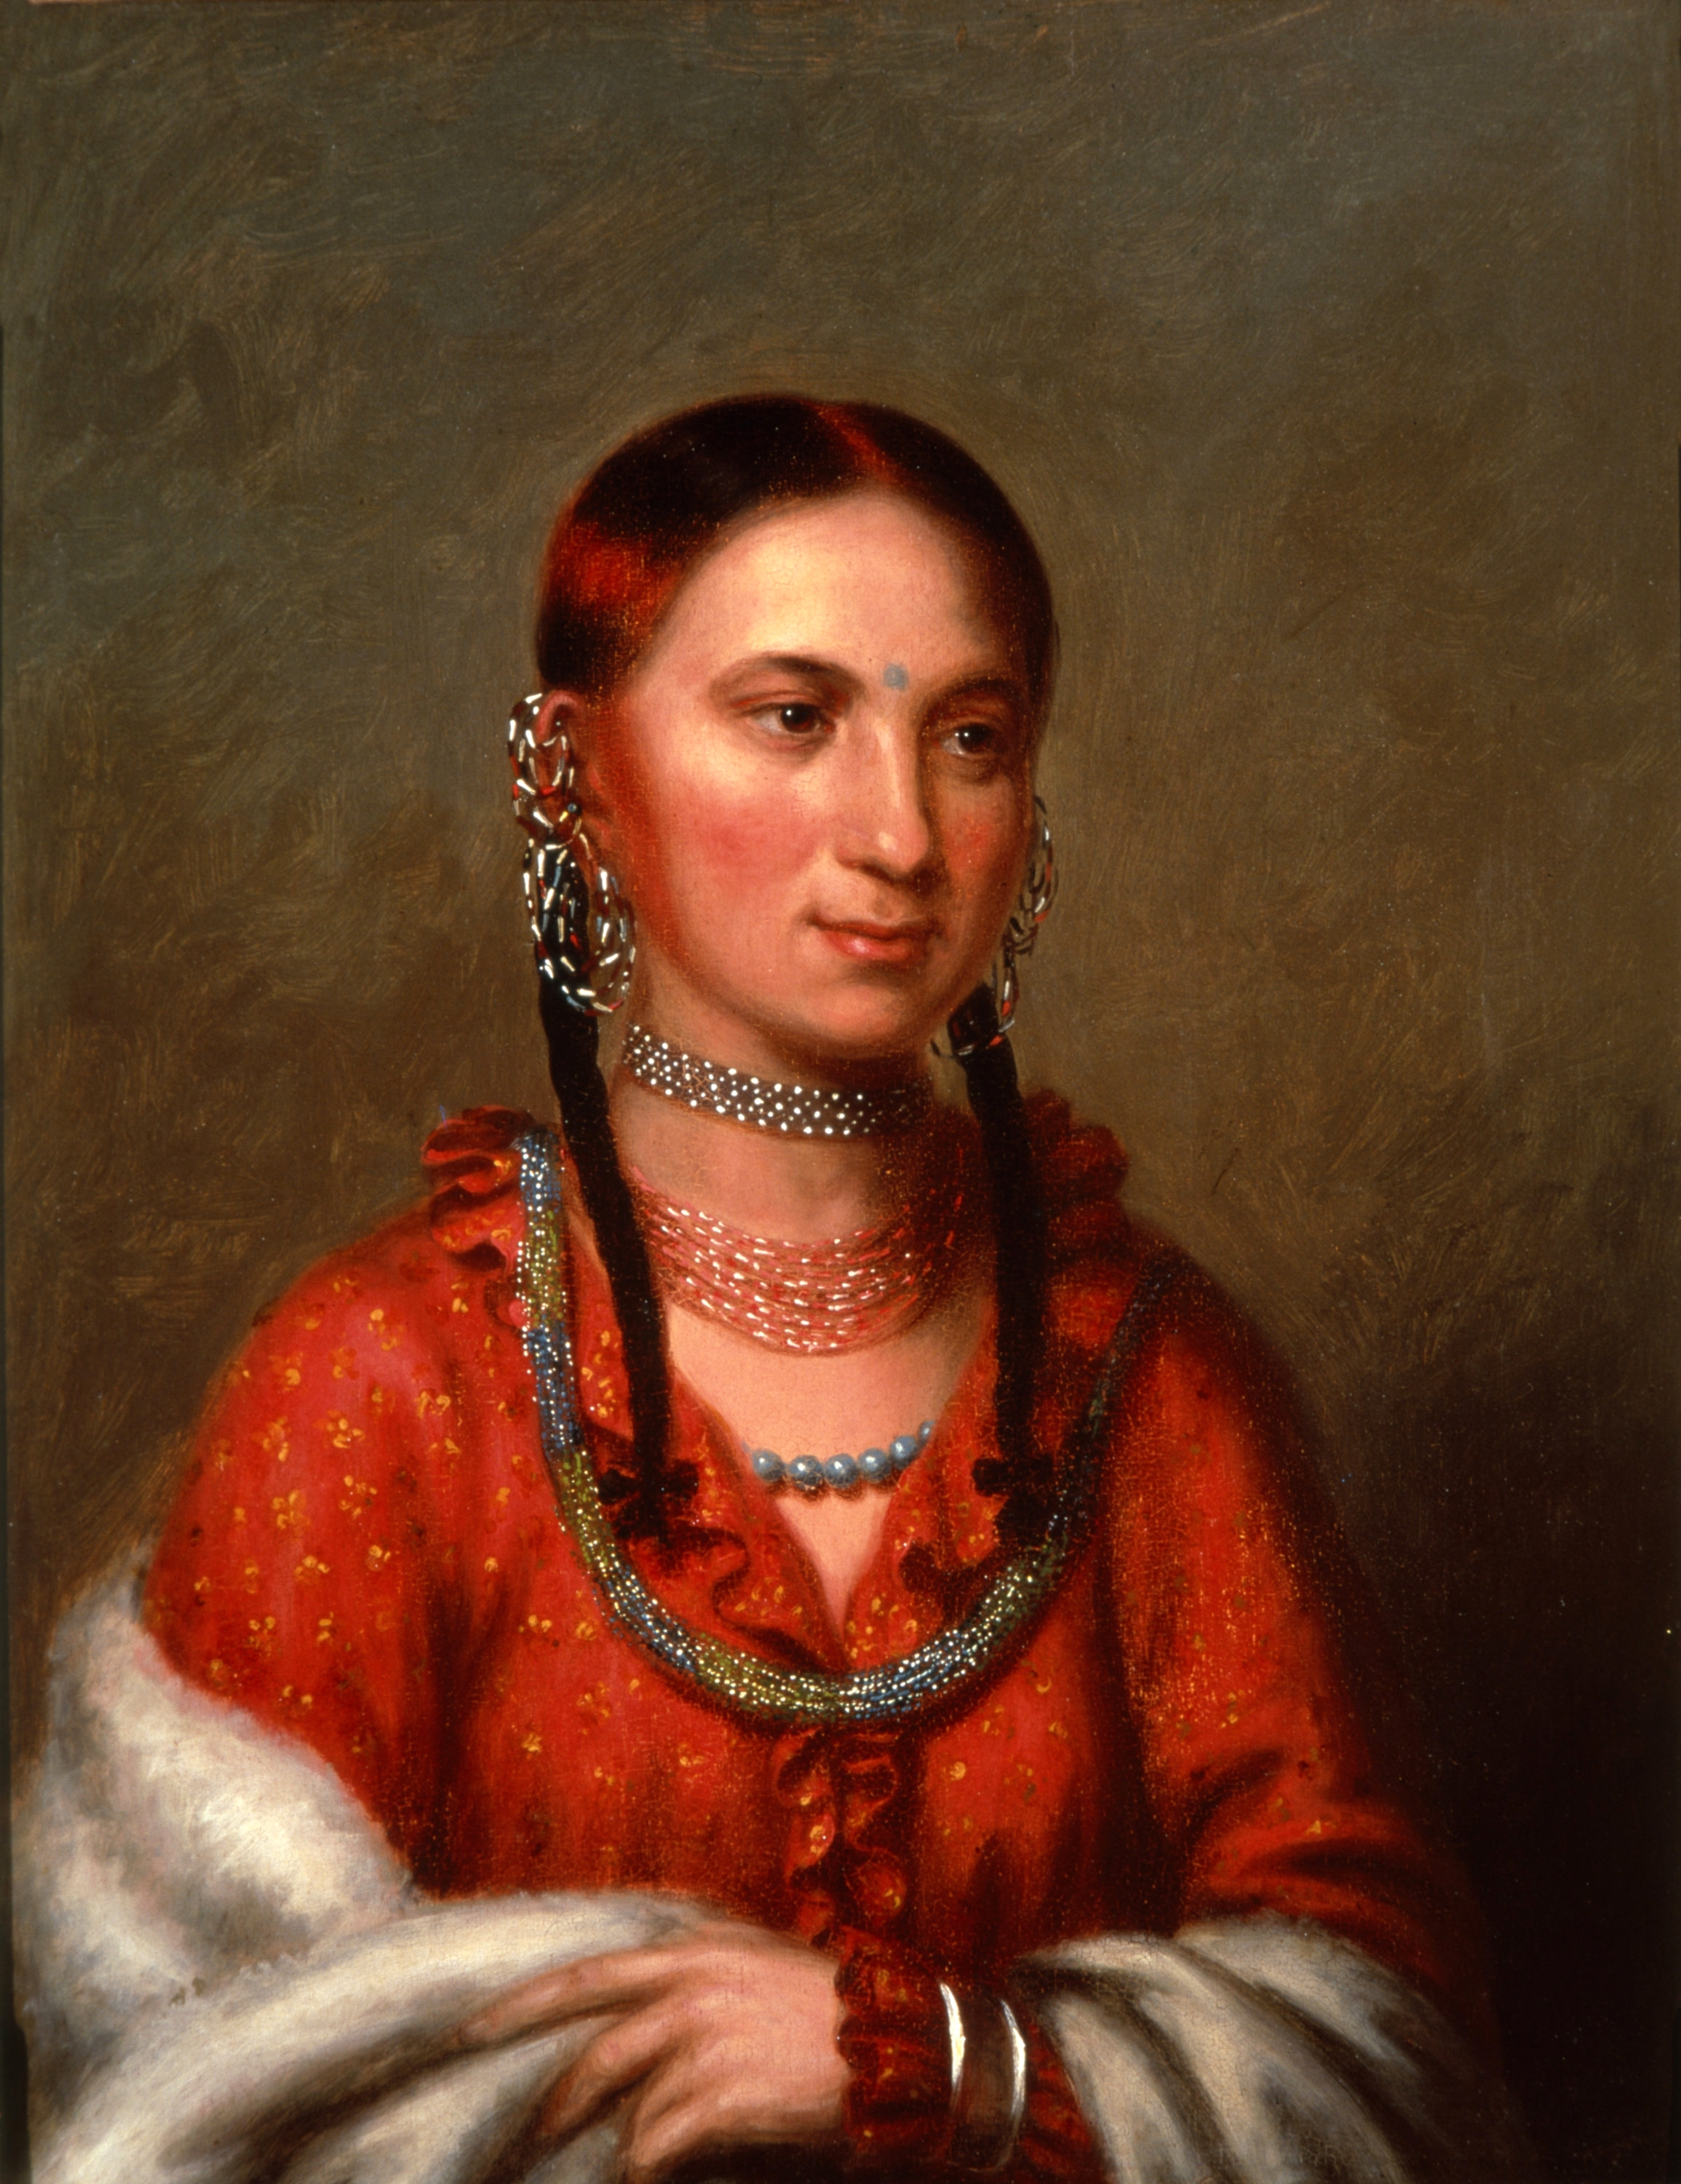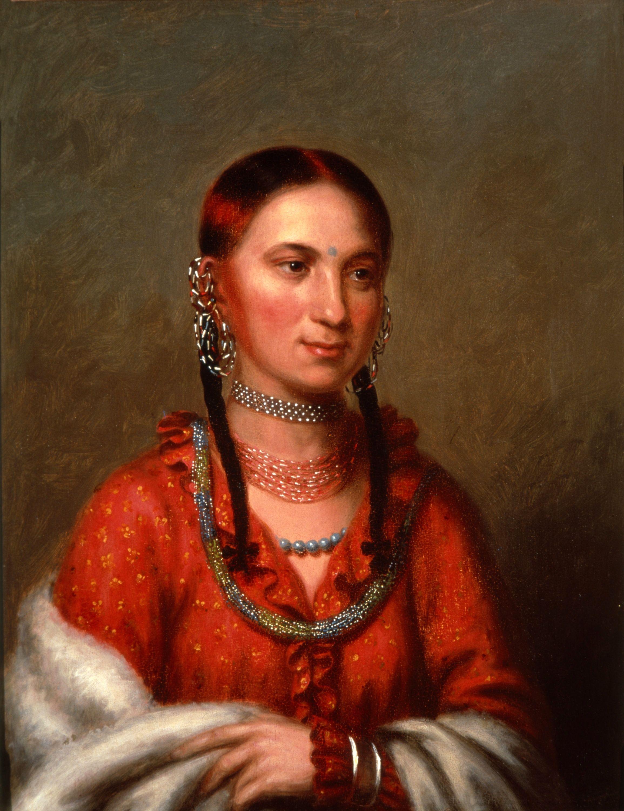

Eagle of Delight (*Hayne Hudjihini*), painted by [Charles Bird King](https://en.wikipedia.org/wiki/Charles_Bird_King), c. 1822

In 1822, she accompanied her husband with an Indian delegation of chiefs to [Washington D.C.](https://en.wikipedia.org/wiki/Washington_D.C.), where they met [James Monroe](https://en.wikipedia.org/wiki/James_Monroe), the [President of the United States](https://en.wikipedia.org/wiki/President_of_the_United_States). She was described by those who met her as beautiful and charming. The [Bureau of Indian Affairs](https://en.wikipedia.org/wiki/Bureau_of_Indian_Affairs) (BIA) commissioned [Charles Bird King](https://en.wikipedia.org/wiki/Charles_Bird_King) to paint portraits of Hudjihini and Shaumonekusse.

Shortly after her visit, Hudjihini died of [measles](https://en.wikipedia.org/wiki/Measles), probably contracted during her travels.[[2]](https://en.wikipedia.org/wiki/Eagle_of_Delight" \l "cite_note-2)[[3]](https://en.wikipedia.org/wiki/Eagle_of_Delight" \l "cite_note-3)

When [Chief Mahaska](https://en.wikipedia.org/wiki/Chief_Mahaska) of the [Ioway](https://en.wikipedia.org/wiki/Ioway) tribe saw Eagle of Delight's portrait in winter 1836-1837 on a visit to Washington DC, and was certain that she was his mother. However, at nearby King's gallery, a copy of Eagle of Delight's portrait hung next to the portrait of Rantchewaime (Female Flying Pigeon), his mother, who he recognized by her fan. It turned out that Mahaska was mistaken because his mother, who had died when he was four, had been a neighbor and close friend of Eagle of Delight. The two women had often dressed in similar colors, and braided their hair the same way. The copy of Eagle of Delight's portrait had added the blue forehead spot, the mark of royalty, which helped him tell the two women apart. Arrangements were made to send copies of the paintings to Chief Mahaska and to Shaumonekusse, who were pleased to have a painting of their mother and wife respectively.[[4]](https://en.wikipedia.org/wiki/Eagle_of_Delight" \l "cite_note-4)

Although the original portrait of Eagle of Delight was destroyed in a fire at the [Smithsonian Institution](https://en.wikipedia.org/wiki/Smithsonian_Institution) in 1865, a patron donated King's personal copy to the [White House](https://en.wikipedia.org/wiki/White_House) in 1962. The portrait now hangs in the [White House Library](https://en.wikipedia.org/wiki/White_House_Library).[[5]](https://en.wikipedia.org/wiki/Eagle_of_Delight" \l "cite_note-5)

## References

• ["Shaumonekusse"](https://archive.org/stream/historyofindiant01mckerich" \l "page/368/mode/2up), *Indian Tribes of North America*, Washington, DC: Smithsonian Institution, 1910, accessed 12 Apr 2020

• • [*"Old map by McKenney - Hayne-Hudjihini the Eagle of Delight."*](http://www.swaen.com/antique-map-of.php?id=9141). Antique Map Price and high resolution image source*. Retrieved 2013-01-31*.

• • McKenney, Thomas L (1872). *[History of the Indian tribes of North America with biographical sketches and anecdotes of the principal chiefs. Embellished with one hundred portraits from the Indian Gallery in the War Department at Washington.](http://www.archive.org/stream/historyofindiant01mckerich" \l "page/n473/mode/2up/search/Shaumonekusse)* Philadelphia: D. Rice & Co*. Retrieved 2013-01-31*.

• • [*"Young Mahaskah, Ioway Chief"*](http://www.accessgenealogy.com/native/biographical/young_mahaskah_ioway_chief.htm). Access Genealogy*. Retrieved 2013-02-02*.

• [*"Portraits of Native Americans in the Library"*](http://georgewbush-whitehouse.archives.gov/history/whtour/library-paintings.html). The White House, President George W. Bush Archives*. Retrieved 2013-02-02*.